

American International University-Bangladesh (AIUB)  
**Department of Computer Science  
Faculty of Science &Technology (FST)  
Spring 20_21  
CSC 2210 Object Oriented Analysis and Design (OOAD)**

**Section: G  
Group No:2**

**PROJECT TITLE: CIVIC CARE**

An Object-Oriented Analysis and Design (OOAD) project submitted

By

|  |  |  |
| --- | --- | --- |
| SN | Student Name | Student ID |
| 26 | Chakraborty, Joydeb | 19-41685-3 |
| 28 | Hossain, Md. Alinur | 20-41855-1 |
| 29 | Rahman, Md. Jidan | 20-41860-1 |
| 31 | Bijoy, Saad Muhammod Bijoy | 20-41880-1 |

The project will be Evaluated for the following Course Outcomes

|  |  |
| --- | --- |
| **CO3:** Formulate a baseline document to perform feasibility study of a proposed project idea | Total Marks |
|  |
| Project Background Analysis [5Marks] |  |
| Project Feasibility Study [5Marks] |  |
| Project Content Knowledge (e.g., diagram scenario narration) [5Marks] |  |
|  | |
| **CO4:** Design a Complex engineering problem using UML Tools and explain the system using a project report and presentation | Total Marks |
|  |
| Completeness, Correctness, and Diagram Standard Tools [5Marks] |  |
| Report Organization [5Marks] |  |
| Presentation Delivery [5Marks] |  |

# CHAPTER 1: PROBLEM DOMAIN

## Project Background Analysis

* Write the background description that helps putting the project into the right context of a problem domain and gives everyone involved a common view of the project

🡪Civic Care is a system for better medical service for the people. This system allows having so many medical services in one place. In our country, most people are illiterate and do not have any idea about the medical service. Most of the time people suffer from the emergency service and the traffic of Dhaka City and other cities also. In this bluffy world, most of the hospitals may give the patient the wrong treatment and they are unknown about that. For this lacking of service, we provide this system. So the civilians of this country can believe in one service and take the correct treatment as they desire. At last, we want to give better and faithful service to all the people.

* What is the root cause of this problem? why is this problem is so important to consider?

🡪We provide Civic Care System for the betterment of the people. Most of the people of Bangladesh are illiterate. That’s why they don’t have any idea about medicines and medical care. Every year 13 out of 18 people die due to a lack of medical help. In the cities, emergency services are very hard to get. Many times they can't reach the emergency places at the exact time. Many hospitals are giving wrong medication and treatments to the patient and they are unknown about this. Peoples are having wrong treatment and service every day.This kind of problem lets people danger their lives. So this problem is so important to consider.

## Project Solution and Feasibility Analysis

* What are the solutions you are going to propose to deal with the problem? why is this   
   solution is particularly appropriate to solve the problem? Is the solution feasible to the   
   meet the business objective?

🡪The problems peoples are facing are emergency medical service, trustable medical service, and proper medication. In our Civic Care system, we are providing better medical service and help to find emergency services also. In the system, the user can find the proper medical center for the proper treatment. The people can trust this service because this contains all the medical services in one place. This service is free of cost.

* Provide a short description of the software being specified and its purpose, including relevant benefits, objectives, and goals.

🡪The goal of this software is to give the people proper medical service. Most of the people in our country are unknown about the proper medical knowledge. This software helps them to find the perfect medical service for them. Because this software is giving all the service in one place. So, it is very easy to use.

* Existing studies presented in the problem area. What are the existing software solutions are available to solve the aforementioned problem?

🡪The software like DIMS, doctime, Medex are giving medical service to the people. But they don’t have all the services included. We are giving all the services in one place so that the software should be user-friendly.

* What makes this project new, innovative, interesting, or otherwise distinct from other similar projects? Does the project duplicate functionality already available in the market?

🡪This software is more user-friendly because in this application we have added all kinds of services like emergency ambulance service, the appointment for the doctor, pharmacy, recommendation for best hospitals, finding nearest hospitals, donations. It also gives healthcare tips to the users every day. Its billing system is also easy to use. It is easy to use. In a word, we can say that this software contains all the services a user needs. There are many software's which is giving this service but they don’t have all the service included. This software is also free of cost. This software helps the user to donate to the hospital through charity if the user wants. Although this software brings new features and it combined all the features in one place.

# CHAPTER 2: UML DIAGRAM

## 2.1 Use Case Diagram

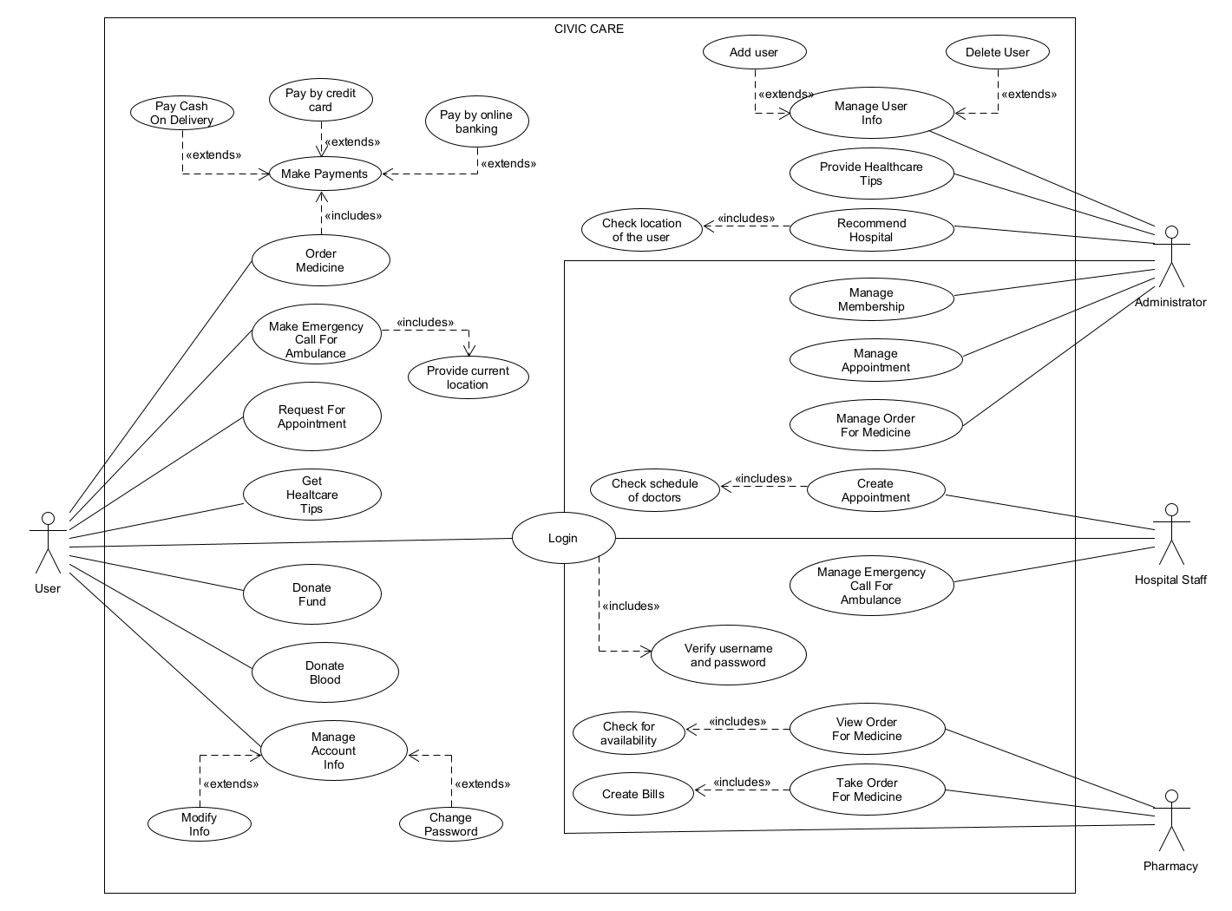

* + Does the use case narrative represent the Scenario of the use case diagram?

🡪In this system, a user can request an appointment, get healthcare tips, order medicines, and can call an emergency ambulance by providing the current location. Also, there is an option for those persons who want to forward their helping hand by donating blood and by donating funds. User can manage his account info where he/she can modify info or change password. The system is handled by the admins. An admin can recommend hospitals for users by checking the location of the user, manage user membership, make appointments, and manage medicine orders. Also, the admin provides some authorized healthcare tips through the system and can manage user's info by adding or deleting users. Hospital staffs have also access to the system where they can create an appointment by checking the schedule of doctors and check the emergency calls. In the pharmacy sector, they can view the medicine orders by checking availability and take orders by creating bills. Users can make payments by cash, online banking, or credit card for the bills. Every actor of this system has to login to the system before using it, but to login, he/she has to go through the username and password verification. This use case narrative represents the scenario of the above use case diagram.

* + Does the Use Case diagram include the major use cases, actors who perform the use cases, and the relationships among the use cases needed to deliver by the system?

🡪Yes, this diagram includes all the major use cases, actors, and the relationships among the use cases needed to deliver by the system.

## 2.2 Class Diagram

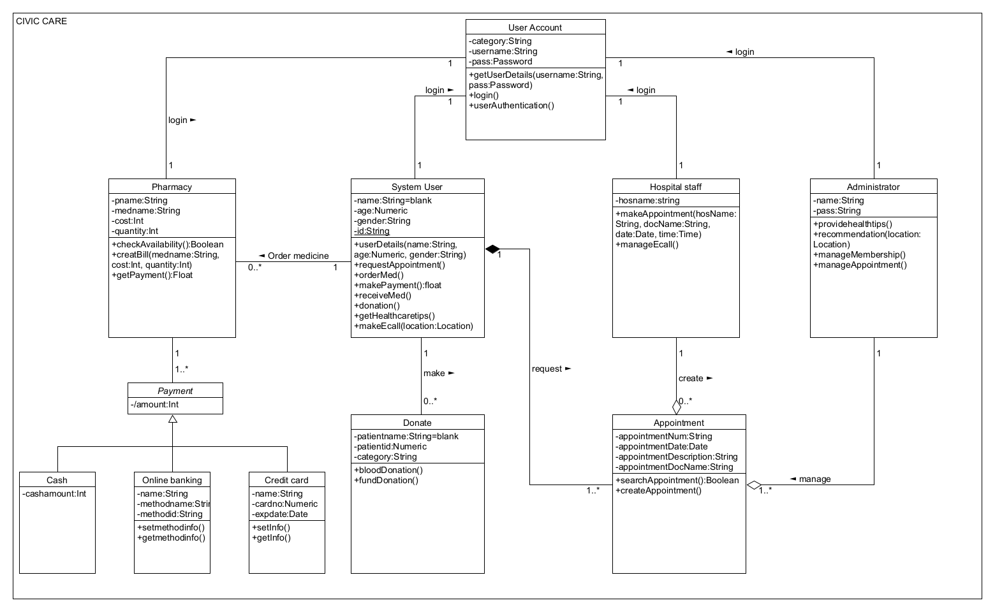

* + Does the class narrative represent the Scenario of the class diagram?

🡪In this system, a user can request an appointment. One or many appointments can be requested by the user and if there is no user request then no appointment will be placed. An administrator can manage one or many appointments. Hospital staff can create an appointment and none or many appointments can be created by them. Users can make donation through donate class where none or many donations can be done by one user. Also, users can order medicine in pharmacy. One user can place none or many orders. There can be one or many payments in pharmacy. Payment can be done by cash, online banking, or credit card. All the users, hospital staffs, pharmacy, and administrator have to login into the system through user account to get access to the system. This class narrative represents the scenario of the above class diagram.

* Does the Class diagram include the major classes (attributes, operations) and the relationship among the classes needed to deliver by the system?

🡪Yes, this diagram includes all the major classes (attributes, operations) and the relationship among the classes needed to deliver by the system.

## 2.4 Sequence Diagram

* Does the sequence narrative represent the Scenario of the sequence diagram?
* Does the Sequence diagram include the sequence of the major activities needed to deliver by the system?

## 2.3 Activity Diagram

* + Does the activity narrative represent the Scenario of the activity diagram?
* Does the Activity diagram include the major activities needed to deliver by the system?

**Text Format**

* Style: Times New Roman
* Size: 12
* Paragraph Spacing: 1.00
* Alignment: Justify
* Length: Maximum 6 pages